**DAILY ONLINE ACTIVITIES SUMMARY**

|  |  |  |  |  |  |  |  |  |
| --- | --- | --- | --- | --- | --- | --- | --- | --- |
| **Date:** | **07-July-2020** | | | | | **Name:** | **RACHANA K N** | |
| **Sem & Sec** | **6th ‘B’** | | | | | **USN:** | **4AL17CS070** | |
| **Online Test Summary** | | | | | | | | |
| **Subject** | | **Computer Graphics and Visualisation** | | | | | | |
| **Max. Marks** | | **30** | | **Score** | | | **-** | |
| **Certification Course Summary** | | | | | | | | |
| **Course** | **-** | | | | | | | |
| **Certificate Provider** | | | **-** | | **Duration** | | | **-** |
| **Coding Challenges** | | | | | | | | |
| **Problem Statement:** **Python program to find the sum of cosine series** | | | | | | | | |
| **Status: COMPLETED** | | | | | | | | |
| **Uploaded the report in Github** | | | | | **YES** | | | |
| **If yes Repository name** | | | | | Daily_status | | | |
| **Uploaded the report in slack** | | | | | **YES** | | | |

Online Test Details:

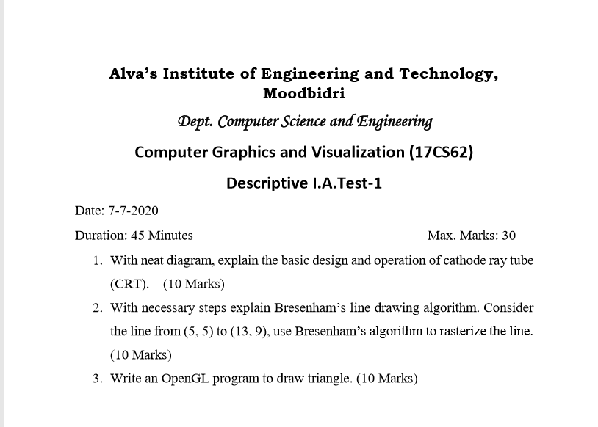

Online Course Details: -

Online Coding Details:

